John Michael Go
Career Entry Level Java Programming
Date: Jan. 14, 2013

DAY 2

Program Name: Donation

Objective: Program will compute for the total tickets sold, gross amount, percentage donated and net sale.

Algorithm:

- User inputs movie name.
- User inputs adult ticket amount.
- User inputs kid ticket amount.
- User inputs adult tickets sold.
- User inputs kid tickets sold.
- User inputs donation percentage.
- Program outputs movie name, number of tickets sold, gross amount, percentage donated, amount donated and net sale.

Flowchart:

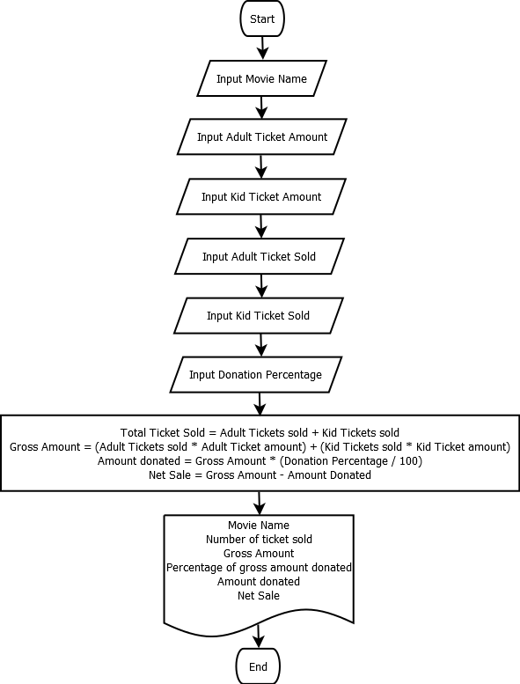

Pseudocode:

Screenshot:

Pseudocode:

import java.util.*;
import java.io.*;

public class Donation{

static Scanner console = new Scanner (System.in);

public static void main(String[]args){
// variable declaration
String movie;
int aTickSold, kTickSold, tTickSold ;
Double AduTick, KidTick, DonPer, GrossAmount, AmtDon, NetSale;

System.out.println ("");
System.out.print ("Enter Movie Name: "); // input movie name
System.out.flush();
movie = console.nextLine();
System.out.println ("");
System.out.print ("Adult Ticket Amount: "); // input adult ticket amount
System.out.flush();
AduTick = console.nextDouble();
System.out.println ("");
System.out.print ("Kid Ticket Amount: "); // input kid ticket amount
System.out.flush();
KidTick = console.nextDouble();
System.out.println ("");
System.out.print ("Number of Adult Tickets sold: "); // input number of adult tickets sold
System.out.flush();
aTickSold = console.nextInt();
System.out.println ("");
System.out.print ("Number of Kid Tickets sold: "); // input number of kid tickets sold
System.out.flush();
kTickSold = console.nextInt();
System.out.println ("");
System.out.print ("Donation Percentage: "); // input percentage of donation from total gross
System.out.flush();
DonPer = console.nextDouble();
System.out.println ("");
System.out.println ("");
System.out.println ("===============================================================================");
System.out.println ("");
System.out.println ("");
System.out.println ("Summary:");
System.out.println ("");
System.out.println ("");
System.out.println ("");

tTickSold = aTickSold + kTickSold; // total ticket sold
GrossAmount = (AduTick * aTickSold) + (KidTick * kTickSold); // gross amount of adult and kid tickets sold
AmtDon = GrossAmount * (DonPer/100); // amount donated
NetSale = GrossAmount - AmtDon; // total sale less amount donated
// display overall computation
System.out.println ("Movie Name: " +movie );
System.out.println ("");
System.out.println ("Number of Tickets Sold: " + tTickSold);
System.out.println ("");
System.out.println ("Gross Amount: " + String.format("%.2f", GrossAmount));
System.out.println ("");
System.out.println ("Percentage of gross amount donated " + String.format("%.2f", DonPer)+"%");
System.out.println ("");
System.out.println ("Amount Donated: " + String.format("%.2f", AmtDon));
System.out.println ("");
System.out.println ("Net Sale: " + String.format("%.2f", NetSale));
System.out.println ("");
System.out.println ("");
System.out.println ("===============================================================================");
System.out.println ("");
System.out.println ("");
System.out.println ("");

}

}

Screenshot:

